Lanark Lodge

Community Newsletter

July 2023

EFT Transfer to Top up Trust
Just a reminder to all residents and POA that when you are sending an EFT (Electronic Funds Transfer to top up the trust account. PLEASE ensure that the residents name is entered in the comment section. When we receive EFTs without the residents name it is very difficult and time consuming for us deposit the funds.
New Rates
The new rates will come into effect on July 1, 2023. You will see this on the July billing which comes out the 1st week of August. Any resident that is in basic accommodation and applying for a rate reduction, must provide me a copy of their Notice of Assessment from Revenue Canada. If you have already completed a CRA Consent form this step is not necessary. If you have any questions regarding this, please do not hesitate to contact Annette Scott on extension 7104.

Tastes Like Home

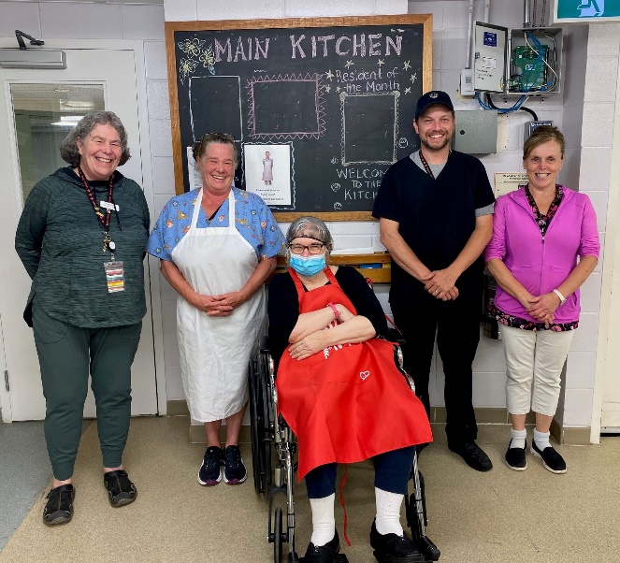

This month’s taste-like home recipe was Claudette Timmerman’s Beef Chop Suey Recipe. We have included Claudette’s recipe for you to make at home. This recipe makes enough to feed 4 people.

-1 pack of ground beef
-Chopped celery
-Peas
-Green Pepper or Red Pepper or both to color to taste
-Tomato Sauce
-Raw Bean Sprouts (canned or fresh) add last. Onions optional

INSTRUCTIONS:
Brown the ground beef over medium heat. Then add tomato sauce and combine. Add vegetables and stir.
Cook until vegetables are tender, add bean sprouts and stir lightly for about 2 minutes. Serve with a side of rice. You can add Soya sauce or Worcestershire sauce on rice.

Serve on side of rice. Add Soya sauce or Worcestershire sauce on rice optional.

Family Council
Lanark Lodge Council of Family and Friends is a valuable contact for family members and friends of any new resident as well as those who may have been part of the Lodge for some time. You can reach council at llfamilycouncil@gmail.com for more information.

