A survey team from 
will be visiting on
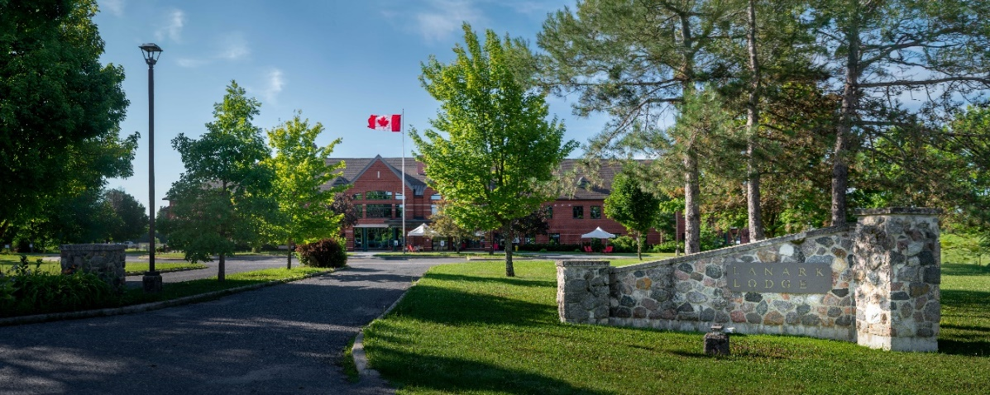
January 15 and 16th, 2026

We invited the surveyors to evaluate how well we meet international standards for quality. The survey will tell us what we are doing well and ways we might improve. As a result of this survey, we may earn accreditation.
As part of the survey, the surveyors will interview residents, their families, our staff, and others. Some questions the survey team members might ask people are:
Do we provide a clean and safe setting?
Do you receive the services you need and want?
Are you treated with respect?
Do you take part in planning your services?
Are you told what you need to know about your services?
Are your questions answered in a way you understand?
Do you know where to go with questions or concerns?

If you would like to talk with one of the survey team members or want to learn more about CARF International, please contact Jennie Bingley, 613-267-4225 ext. 7104 or jbingley@lanarkcounty.ca
You may also contact CARF International directly:
Mail: CARF International, 6951 East Southpoint Road,
Tucson, AZ 85756 Email: feedback@carf.org Internet: www.carf.org/contact-us Fax: (520) 318-1129
Toll-free telephone: (866) 510-2273 * CARF International — A group of companies that includes CARF, CARF Canada, and CARF Europe.

