Tax season is approaching quickly. The 2025 Accommodation Summaries were mailed out in early January. Should you require an additional copy, please
contact Alana at adraper@lanarkcounty.ca or extension 7113
As a reminder, if you are currently receiving a rate reduction, a copy of the resident’s Notice of Assessment must be provided BEFORE July 2026 to ensure continued eligibility.


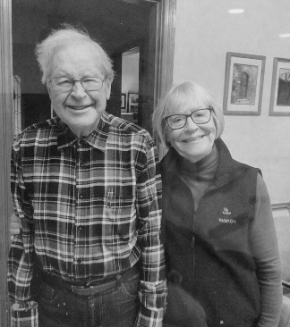
now…

If you are visiting us this month…
& then…



Watch for our ‘Sweetheart’ photo wall showcasing
the great love stories of our residents…

Friendly Reminder of our Dinning Room Mealtimes

Yesterdays Dinning Room
(Maples Small Room)
Breakfast-8:10
Lunch-12:10
Dinner-5:10
Courtyard Dinning Room
(Maples Large Room)
Breakfast-8:20
Lunch-12:20
Dinner-5:20

Glenview (Oakridge)
Breakfast-7:45
Lunch-11:45
Dinner: 5:00
Blue Skies (Evergreens)
Breakfast-8:30
Lunch-12:00
Dinner-5:00


Audrey’s Kitchen (Honeysuckle)
Breakfast-8:00
Lunch-12:00
Dinner-5:00

Visiting at Lanark Lodge
**Feeling unwell? Please postpone your visit, until you are feeling better**
We feel that it is important for the residents to visit with friends and family as much as possible. We ask that your visitors come between the hours of 8:00am to 8:00pm, as that is when our visiting doors are unlocked.

