

CONNECTIONS

April 8, 2026 – Mother’s Day Photoshoot! The Photography Club has generously donated their time for a Mother’s Day Photoshoot on April 8th in the Auditorium. Sign up is required! Limited Spaces. Please contact the front office to book your 15-minute session at 613-267-4225 x7103.


Adaptive Clothing Sale! Tuesday, April 28th
from 10 am to 3 pm in the Auditorium.
Adaptive clothing has features such as closures
that are more suitable for residents who may be dependent on others. Adaptive clothing allows for more ease with dressing and undressing as well as other activities of daily living.

NEW dining room chairs!
Our new dining chairs are scheduled to arrive in April to replace the current ones. This upgrade is in follow-up to feedback received from our Residents’ Council.
Upcoming Renovation
Our Kitchen renovation project is scheduled to begin April 20th and is projected to take 3-4 weeks. Our Main Kitchen is getting an upgrade which means that we will be preparing our meals in a temporary location during this time. Changes to the menu have been made in the interim. The temporary menu has been approved by the Registered Dietitian of the home, Milène Hurdis and the members of Residents’ Council. The dietary department has partnered with Public Health, the Ministry of Longterm Care and the local Fire Department to ensure that guidelines and regulations meet resident safety. We thank you in advance for your understanding and patience while we undergo this large-scale project.
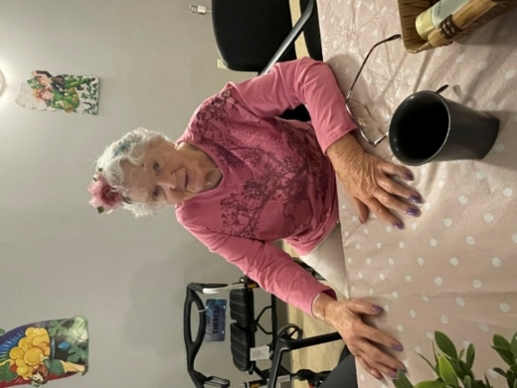
SPA DAY! Our recreation team has been hosting weekly spa
days in the Auditorium. The spa features facials, hand massages,
manicures, foot soaks and refreshments.
Resident, Theresa enjoying a manicure.

Happy Easter!
Good Friday – April 3rd Easter Monday – April 6th
Please note the business office at Lanark Lodge will be closed for the Easter weekend from Friday to Monday – with limited front desk coverage on Friday.

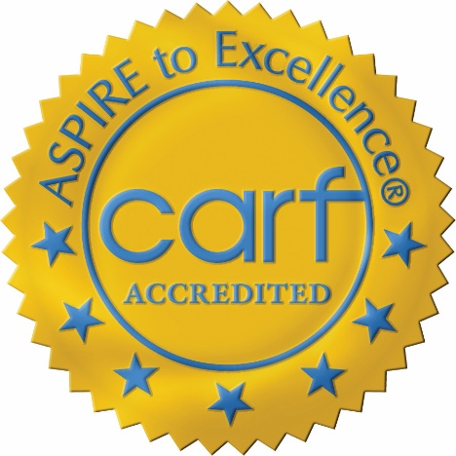
Accreditation! We are pleased to report that we have achieved a three-year accreditation status through CARF following the onsite survey on January 15-16, 2026. CARF accreditation is an external peer-review that recognized Lanark Lodge for meeting high standards in quality, safety, and continuous improvement. This designation benefits the home by demonstrating commitment to excellence, helps the public identify trusted service providers and provides additional funding from the Ministry of Long-Term Care. The net financial benefit to the home is approximately $40,000 over the three-year accreditation.

Resident Council meetings will be held on the 2nd Tuesday of each month at 3:30pm in Honeysuckle Round Room. We kindly ask

that families encourage their loved ones to attend. This is a space for residents to speak freely and openly in a collaborative manner.

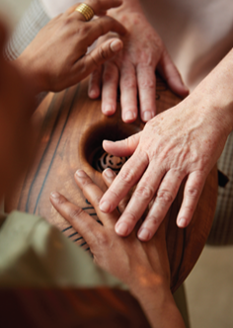
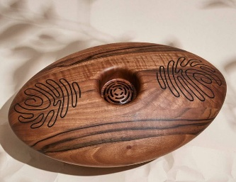
NEW Musical Instrument – CRDL Program: Lanark Lodge has received funding through the Center for Aging + Brain Health Innovation. This funding has enabled our Home to implement the Crdl [Cradle], a musical instrument that creates meaningful connection between people with physical or cognitive impairment. It allows us to connect with our residents in more meaningful ways and provides a sensory experience that creates music through touch.
The Crdl is used by two or more people, where each person places their hand on the conductive pad on the Crdl instrument. Then when the person touches the other person, it completes the circuit and creates a sound. The Crdl recognizes the manner and intensity of touch and translates this into different sounds.
Our Associate Director of Care, Nicole Wright oversees the Crdl Program, and we would like to involve our families in the Crdl’s use. Please reach out to Nicole if you would like to learn how to use the Crdl instrument with your loved one(s) and to set up access to it.
Nicole can be reached at: 613-267-4225 x 7207 nwright@lanarkcounty.ca

