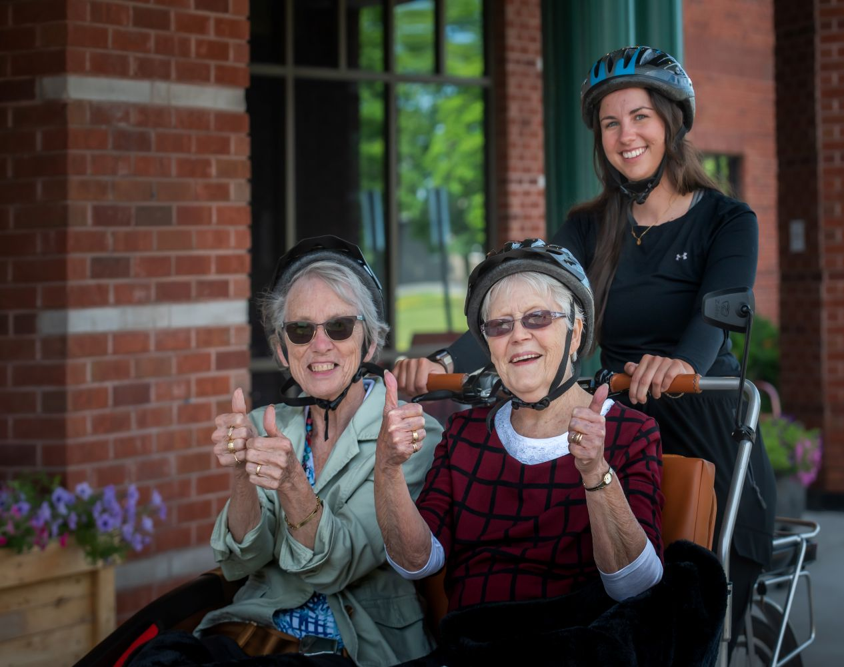

CONNECTIONS

TRISHAW: CYCLING WITHOUT AGE
Pictured on the right is our trishaw, a 3-wheeled bike with a two-seated carriage for passengers in the front. A trained staff controls the trishaw from the bike that is located behind the passengers. This special design enables conversation between the pilot and residents who are enjoying a ride.
If you feel that your loved one would enjoy this experience, please reach out to our recreation team. We will then complete an assessment along with our physiotherapy team to ensure they are able to transfer and ride. Please email Stacey and she will direct your inquiry to the appropriate recreation team member. Stacey: smccord@lanarkcounty.ca
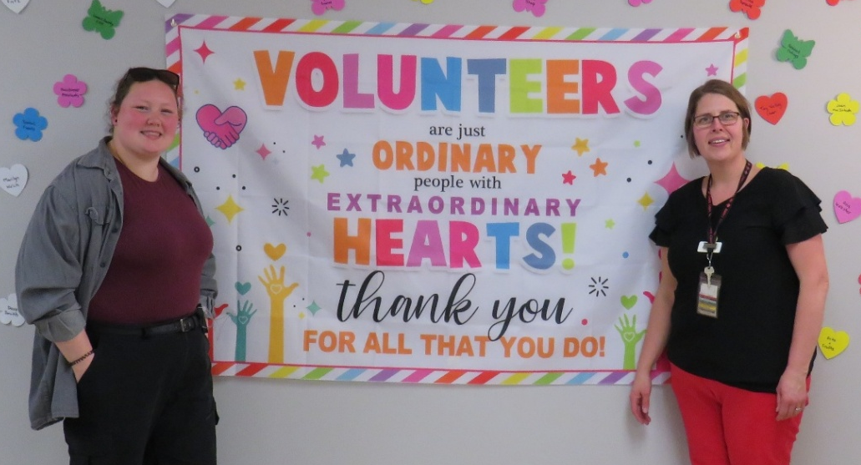
In May we hosted our Annual Volunteer Appreciation event to celebrate all our dedicated volunteers. Everyday we value all that our volunteers do to make a difference at Lanark Lodge!
If you are interested in volunteering with us, please reach out to Donna Hart our volunteer coordinator.
Donna: dhart@lanarkcounty.ca

MAPLES CALENDAR
Starting in June, the Maples Neighbourhood will return to having its own dedicated activity calendar. While Maples residents will continue to participate in all home-wide community events, Maples will also offer additional individualized programming in the mornings and evenings.

The Maples calendar will be available on the website, and printed copies will also be posted on the Maples communication board for easy access.
WE OFFER MUSIC THERAPY
Music therapy is an evidence-based practice wherein music and or elements of music are used to accomplish goals, like reducing stress,
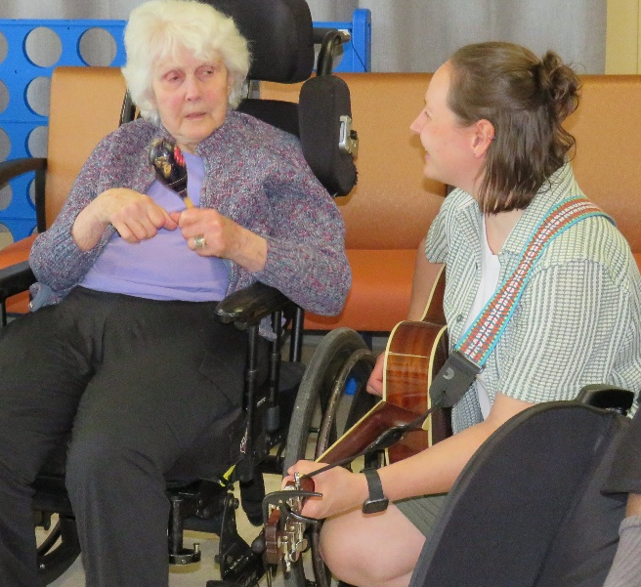
promoting social engagement or improving quality of life. A certified music therapist designs each session specifically for their clients. You can sign up for this service to be charged to the resident trust account at $12 per session. Music therapy experiences may include listening, singing, playing instruments or writing music. Our certified music therapist, Shannon, is pictured here with one of our residents during a Music Therapy session in May. Please see the front office if you are interested in signing up.

MEMORIAL SERVICE on Wednesday, July 15th at 10:00 a.m. in the Auditorium we will gather to celebrate and remember all the residents we have lost this year. This service will be conducted by our Spiritual Volunteer, Clint Halladay. Invites will be sent out in June for families who have lost a loved one during the first part of 2026.

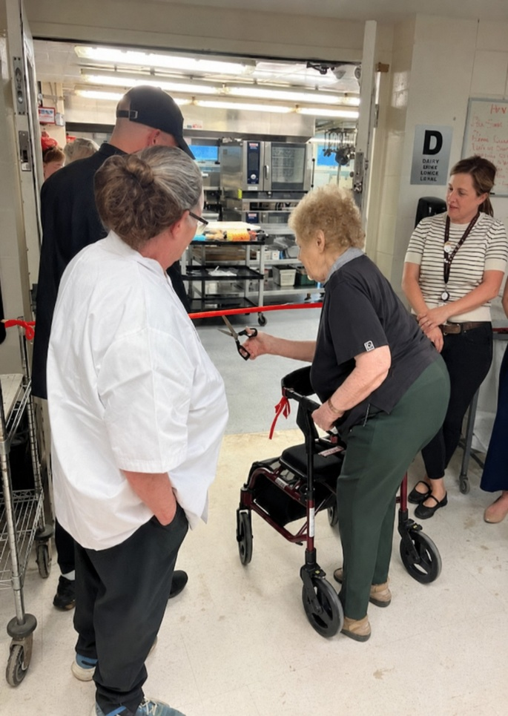
A MESSAGE FROM YOUR DIETARY DEPARTMENT

Residents, Families and Staff were in attendance while the dietary department celebrated the grand reopening of the kitchen on Thursday May 21st. Members in attendance were given the opportunity to tour the newly updated kitchen and meet the members of the production team. The kitchen renovation project started on Thursday, April 23rd and was completed by Friday May 15th. The members of the dietary team transitioned seamlessly into their 28-foot kitchen trailer where they produced a total of 10, 758 meals. The home will be transitioning back to its original menu cycle by next week. We want to take the opportunity to thank all the Residents and their families for their patience and understanding during this busy time.

