
CONNECTIONS
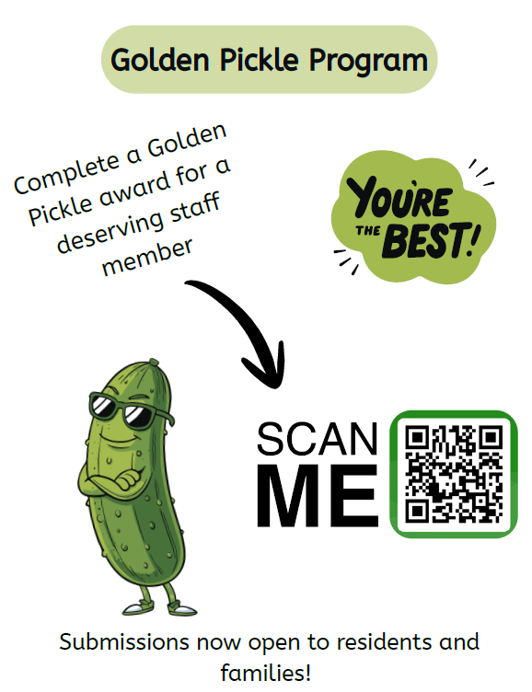
The Lanark Lodge Golden Pickle Staff Recognition Program:
Our peer-to-peer recognition program was created to recognize team members for going above and beyond. We would like to extend this program by giving residents and families the opportunity to also recognize our team members. How it works:
- Scan the QR code on the poster and include the reason you would like to recognize the staff member.
- Each golden pickle winner will be recognized for their “good deed” and be awarded a golden pickle label pin.
- All submissions will be reviewed monthly by the spirit committee, and one team member will be selected as the grand winner.
- The monthly winner will win the preferred monthly parking pass and receive a generous gift card.

Dining Room Chairs
Our new dining room chairs have arrived giving our dining rooms a brighter and more modern look. Feedback from our Residents has been positive.

Kitchen Renovation
The dietary department launched their temporary Renovation Menu on Monday April 20th while transitioning into the mobile kitchen. Residents will be offered one hot meal entrée for lunch and supper with a choice of sides. We want to thank residents in advance for their understanding and patience while we undergo this large project.


Exciting News! Lanark Lodge has partnered with EarlyON! We will be hosting a monthly playgroup where residents will be welcomed to socialize with babies & toddlers.
Our first intergenerational playgroup will be hosted on Tuesday, May 26th starting at 10am in the Auditorium!

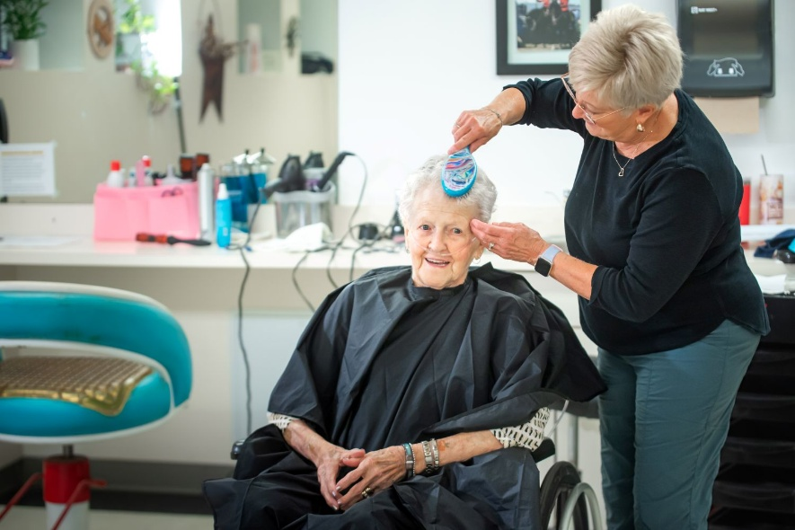
Notice of Price Change:
Our perms will be increasing from $70 to $75 effective June 1st, 2026.

Below are our current prices for
hairdressing services:

BANGS / BEARD TRIM $ 5.00
SHAMPOO ONLY $ 5.00
BUZZ CUT $18.00
PERM (includes cut and Style) $70.00 Changing to $75 June 1, 2026
CUT / STYLE $28.00
CUT / BLOW-DRY & SET $32.00
COLOUR / CUT & BLOW-DRY $55.00
ROLLER SET / BLOW-DRY $25.00
with CURLING IRON

If at any point you would like to add or remove a service, please contact the business office at Lanark Lodge.

