
CONNECTIONS
Lost & Found Event!
Please watch for more information about our Lost & Found Event taking place this fall! This will be an opportunity to walk through our Auditorium to reclaim Resident belongings!
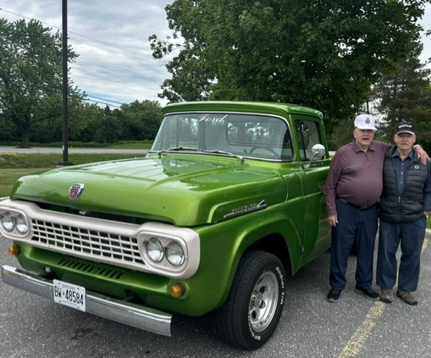

Residents enjoyed Our Car Show earlier this summer!
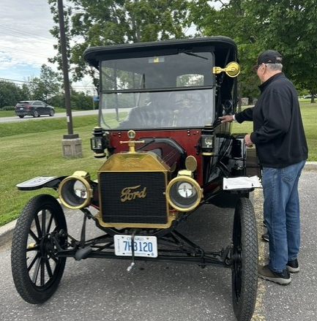
Please note effective September 1, 2026, there will be a price increase for group Music Therapy. The fee will be $15/ session.
If you are interested in this unfunded service, you can sign up at the business office Monday through Friday from 8:30 to 4 pm.
NEW Guest WiFi!
Please look for the password posted throughout the home on BLUE paper.
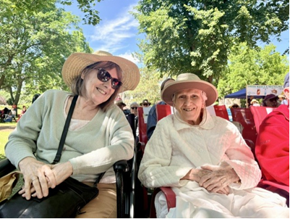
Stewart Park Festival 2026
The Lanark Lodge recreation team along with some of our residents took to the Stewart park festival for the 3rd year in a row. The residents enjoyed a picnic lunch while listening to the music. They later got to enjoy an ice cream treat. We look forward to doing more trips in the future.

