
CONNECTIONS

Recreational Outing: A few of our residents recently had the chance to talk about living at Lanark Lodge and participate in some activities with the Grade 1s at Queen Elizabeth School.


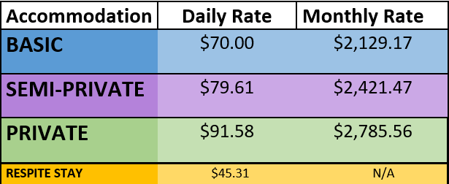
Accommodate Rate Change: We previously sent out notices stating the change in Accommodation Rates as of July 1, 2026 – This is a reminder of the rates now in effect. The first charge to reflect these fees will be in August.



Lanark Lodge Tuckshop: Joan is one of our volunteers we are very lucky to have! Pictured below on the right is Joan next to our recreation team member, Kacie. You may recognize Joan as she comes in every Wednesday, (often accompanied with Dave), to operate our tuckshop and serve our residents! If you would like to sign your loved one up for consent to access our tuckshop – please do so through the front office.
Our current tuckshop price list:

